Social Media Engagement in Marketing

Background
Social media reveal Market-consumer intimacy because it acts as an indicator of a close and inward relationship between consumers and a product or service (Dolan et al., 2019). Most consumers use a brand's social media accounts to interact with the products or services they offer before making a purchase decision.
Therefore, the concept of marketing has to be effectively intertwined with social media in order to ensure the success of any given brand. Social media engagement as a tool to boost marketing has significant advantages, including; promoting products and services, increasing brand awareness, generating conversations around a brand, telling the brand's story, and connecting with current and prospective clients.

Guidelines to increase social media engagement.
- Analysis of current and prospective engagement
- Selection of a social media engagement strategy
- Identifying the target audience
- Creating and sharing valuable content
- Talking about current events
- Keeping the social media accounts active
- Revealing the human side of the brand
- Ensuring timely responses
- Scheduling content to post on the various social media sites
Since it is difficult for an organization to measure the growth of a project without knowing when and how it started, marketers should focus their attention on analyzing the firm's current social media engagement before moving forward to create better strategies that will bring about overall success in the business operations. After a careful analysis of current social media engagement and deciding the way forward, the marketing department should proceed with selecting a strategy to use for engaging the target audience using social media platforms (Song & Park,2020). The strategy should strive to meet goals such as shifting the public's perception towards the brand, establishing new customer leads, gathering feedback on new products or services, and keeping the audience engaged and educated.
Audience analysis is another valuable tool for ensuring social media engagement for marketing purposes. A business should conduct in-depth research about their current and prospective customers to better understand their traits in terms of age, education level, social status, beliefs, attitudes, and geographical location. Audience analysis will enable the business to determine how to structure their online posts so as to ensure they appeal to their audience and generate positive responses. Successful social media engagement for a business is not about posting just any type of content; a business should be sure to create and disseminate valuable content (Song & Park,2020). The online audience needs to feel that the information posted on the company's online sites is useful in terms of educating them about the brand or how to use a given product, its benefits, its cost, and its relevance while still maintaining a conversational tone.
Valuable content can be in the form of Q and A's, polls, contests, customer spotlight, and did you know posts. The only way to develop relevant content is to be keen on what the clients want and giving it to them as they want it. In the online space, it is not about just giving but also receiving. For impactful results in marketing, social media strategies need to be both active and proactive.
Being pro-active enables the business to start online conversations and inform the market while being reactive is inclusive of responding to their questions and concerns about the brand effectively. For success in marketing, an organization needs to ensure they are consistent in posting online. This requires a schedule to be created to determine what content to post weekly, monthly, and annually. In addition, there should be speedy responses to any concerns or questions raised by online audiences to ensure they feel like their concerns are taken seriously.

Pest Analysis
……………. Add (put them in table)

Social media tools for marketing
Post Planner is a social engagement tool that can be used to access content that is already performing well on different social media platforms (Dessart, 2017). This ensures that the content posted is relevant and familiar to the audience. Post Planner also schedules the content and posts it, but it can be used to find the content depending on the organization's marketing department's preferences. Post planner makes the work of content marketing easier and more impactful.
One Stream is a tool that is used to produce high-quality video content and then schedules it to go up on different social sites at a given time. It helps determine the best time to go live, as one can tell by the number of engagements each time there is a live video. It is a relevant tool because it can be used with different social media sites, including YouTube, Twitter, and Facebook.
Social searcher is a social media marketing tool that enables the firm to keep on top of social conversations and respond in a timely manner. Responding on time ensures that the conversation with clients is kept going and interesting, thus allowing room for persuasion to take place. Social searcher also enables the firm to track any negative reviews, comments, and feedback early enough and respond appropriately to avoid brand damage. Social media makes it easy to identify trending hashtags, the right time for content posting, and what social media platforms to pour more attention on to ensure success in marketing.
Social pilot is a tool that enables the control of all the social media platforms, using it as a central place (Fan & Gordon,2014). It is favorable because it also comes in the form of a mobile application, making it easier to monitor social platforms while on the go. Social pilot makes it easier to monitor and schedule posts that will generate increased sales from one location.
Hashtag tracker is a social engagement marketing tool that enables creating and using relevant and trending hashtags to ensure content creation and audience engagement. Choosing the right hashtag is key to increasing visibility. Studies show that Instagram posts that use hashtags get more attention than those which do not use hashtags. Figure 3: https://www.clickz.com/what-makes-people-follow-or-unfollow-a-brand/

How to measure social media engagement in marketing
It is important to know that each social media platform has its mechanism for users to express themselves, and therefore the measuring metrics are different for each of them. For
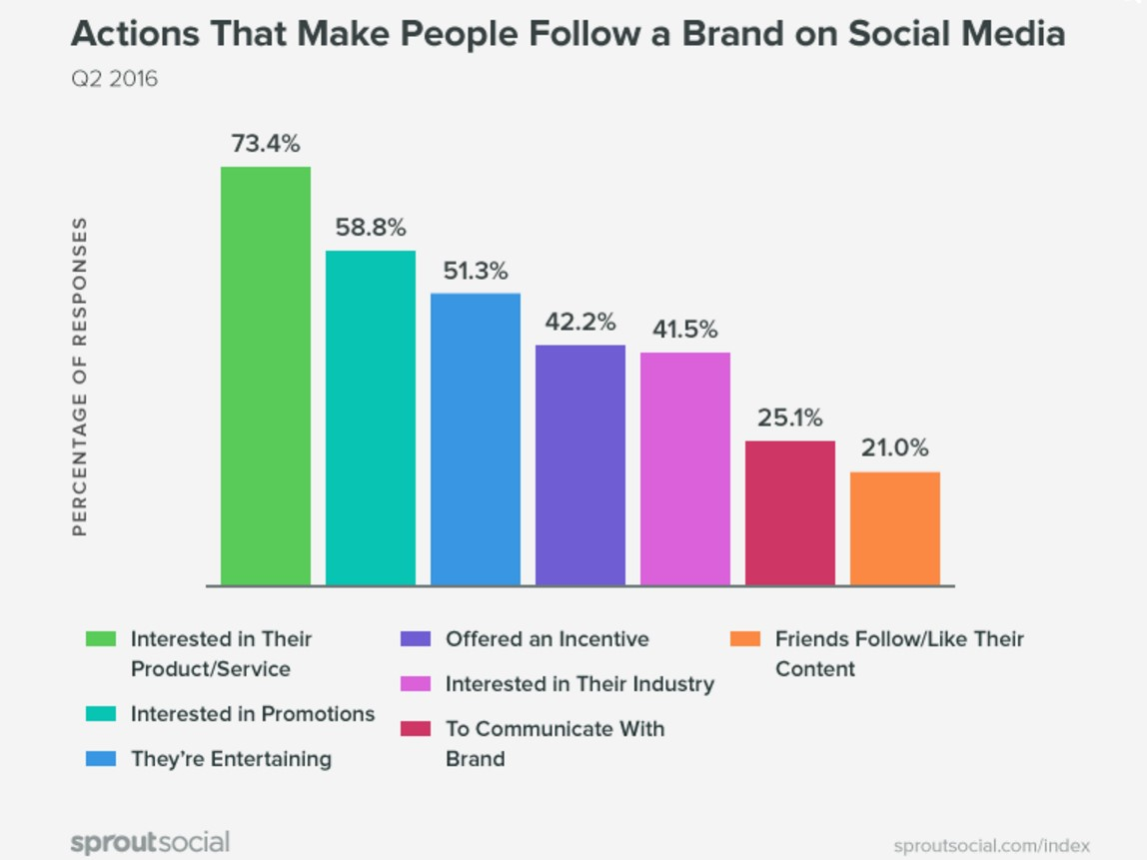
Twitter, you need to keep track of the average tweet performance for every post that is made. This is done by checking the number of retweets, shares, and comments that the post has generated and its length. Twitter also has metrics that inform you of the type of audience that is attracted to your post. This is very useful in guiding you on what kind of content to keep posting in the long run. Twitter happens to have a feature that can tell the account holder the kind of engagement their post
generated in terms of the number of clicks it got, the profile clicks, the detail expands, and media engagements. Twitter has an analytic page where one can access and check the engagement rate represented as a percentage.
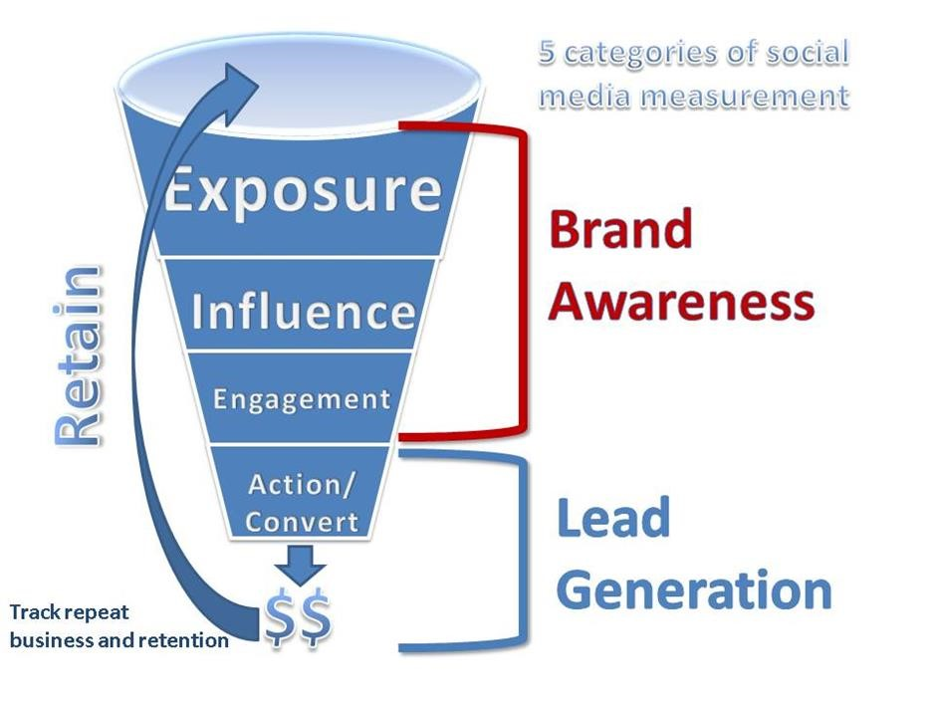

Figure 4: https://www.socialmediaexaminer.com/4-ways-measure-social-media-and-itsimpact-on-your-brand/
The simplest method of measuring the social engagement rate in Facebook is checking the number of likes and shares. The other metric for establishing Facebook engagement is the growth rate system that tells you about how many followers your site has gained over the last few weeks, months, or years. In addition to following, a business should also track the percentage of active followers on Facebook so as to be more informed on how to keep them engaged.
For Instagram, engagement is measured on the basis of follower growth in a given duration of time. It is vital to check the rate of unfollowing that Instagram experienced to determine what could have caused it to happen. Comments are another helpful feature in determining how the rates of engagement are on Instagram. A business can also measure their reach on Instagram by the number of impressions their profile receives and the percentage at which the results change. Lastly, measurement can be done by checking the hashtags that generated the most reactions after they were used in content that was posted.
On linked-in, measurement of engagement is done by checking the following rate on a businesses' page. The total number of new followers, organic followers, sponsored followers, and their demographics are vital metrics to use for measuring engagement in Linked-In. In addition, the number of likes, shares, profile views, video views, and post views are vital metrics for measuring engagement.

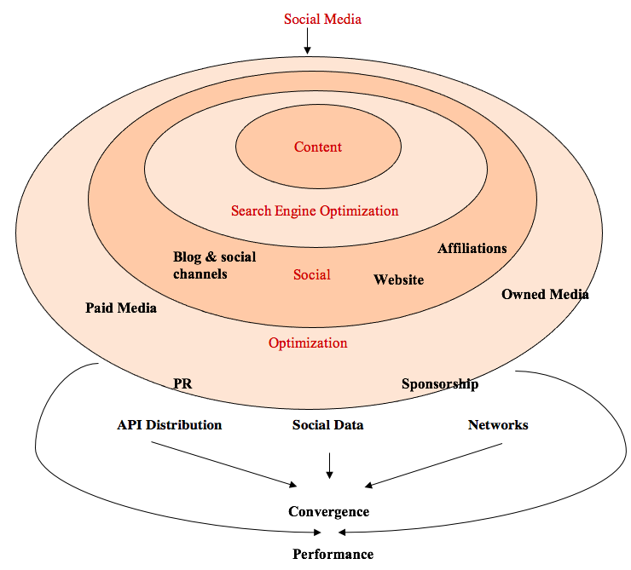
Social Media Ripple Effect

Add a paragraph or a bullet point explaining about it.

Swot Analysis
………… add (put them in table)

Importance of Social engagement in marketing
Social media engagement helps a business have a wider reach and increase customer loyalty and trust, which translates to increased sales and profits (Kurniawati, Shanks & Bekmamedova,2013). Once the audience is aware of a brand, they share it with friends and other online users, thus resulting in wide reach. Social engagement helps show the human side of a business through frequent interactions with online audiences. When an audience relates to a brand's human side, they are more likely to be active users of the products or services it represents.
Brand awareness is also promoted due to social media engagement. Social media engagement helps tell a brand's story and generating conversations around the brand. Lastly, social media engagement is necessary for a business since it aids in the gathering of feedback that the business uses to improve their products, services, and interaction techniques with their current and prospective clients.

Conclusion
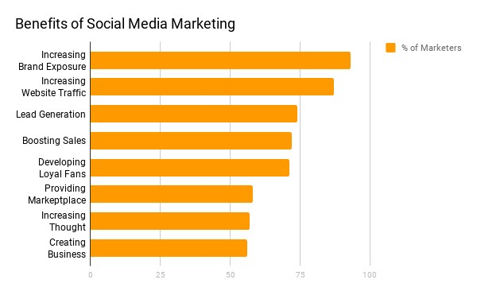
Social media networks are an even opportunity for all businesses to interact and influence their client's purchase decisions. There are many social networking sites to choose from to suit each business's needs. However, social media engagement should be done using the right tools and strategies to ensure it boosts marketing. If done correctly, social media engagement will increase sales for a business, save on costs, improve brand recognition, customer loyalty, customer satisfaction, and engage customers effectively. There is no denying that social media marketing can help any business stay ahead of the competition.

Figure 5: https://www.smallbizgenius.net/by-the-numbers/social-media-marketing-statistics/#gref

References
Chirumalla, K., Oghazi, P., & Parida, V. (2018). Social media engagement strategy: Investigation of marketing and R&D interfaces in manufacturing industry. Industrial Marketing Management, 74, 138-149.
Dolan, R., Conduit, J., Frethey-Bentham, C., Fahy, J., & Goodman, S. (2019). Social media engagement behavior: a framework for engaging customers through social media content. European Journal of Marketing.
Hollebeek, L. D. (2019). Developing business customer engagement through social media engagement-platforms: An integrative SD logic/RBV-informed model. Industrial Marketing Management, 81, 89-98.
Song, S., & Park, K. (2020). Thematic analysis of destination images for social media engagement marketing. Industrial Management & Data Systems.
Dessart, L. (2017). Social media engagement: a model of antecedents and relational outcomes. Journal of Marketing Management, 33(5-6), 375-399.
Fan, W., & Gordon, M. D. (2014). The power of social media analytics. Communications of the ACM, 57(6), 74-81.
Kurniawati, K., Shanks, G., & Bekmamedova, N. (2013). The business impact of social media analytics.

